**VNR Vignana Jyothi Institute of Engineering &Technology**

(Autonomous Institute, Accredited by NAAC with ‘A++’ grade and NBA)

Bachupally ,Nizampet(S.O)Hyderabad-500 090,

**A Project Report on**

# **Eduprime Clone**

**Submitted in the fulfilment of the requirements for the Mini project**

**of**

**BACHELOR OF TECHNOLOGY**

**in**

**INFORMATION TECHNOLOGY**

Submitted by

|  |  |  |  |
| --- | --- | --- | --- |
| Akhil Nalla |  |  | 19071A12C1 |
| Md. Irshad Ahmed |  |  | 19071A12F3 |
| Ch Mohan |  |  | 19071A12F4 |
| Venkata Sai Gaman |  |  | 17071A12H7 |



**DEPARTMENT OF INFORMATION TECHNOLOGY**

**VNR Vignana Jyothi Institute of Engineering &Technology**

(Autonomous Institute, Accredited by NAAC with ‘A++’ grade and NBA)

Bachupally ,Nizampet(S.O)Hyderabad-500 090,

November 2022

**A Project Report on**

**Medicine Reminder**

**Submitted in the fulfilment of the requirements for the Mini**

**project of**

**BACHELOR OF TECHNOLOGY**

**in**

**INFORMATION TECHNOLOGY**

Submitted by

|  |  |  |  |
| --- | --- | --- | --- |
| Akhil Nalla |  |  | 19071A12C1 |
| Md. Irshad Ahmed |  |  | 19071A12F3 |
| Ch Mohan |  |  | 19071A12F4 |
| Venkata Sai Gaman |  |  | 17071A12H7 |

**Under the esteemed guidance of**

**PROJECT GUIDE**

Dr.G. Naga Chandrika

Assistant Professor,

Dept. Of Information Technology,

VNRVJIET



**DEPARTMENT OF INFORMATION TECHNOLOGY**

**VNR Vignana Jyothi Institute of Engineering &Technology**

(Autonomous Institute, Accredited by NAAC with ‘A++’ grade and NBA)

Bachupally ,Nizampet(S.O)Hyderabad-500 090,

**VNR Vignana Jyothi Institute of Engineering & Technology**

Autonomous Institute, Accredited by NAAC with ‘A++’ grade and NBA) Bachupally, Nizampet (S.O.) Hyderabad- 500090.

## Department of Information Technology

**DECLARATION**

I hereby declare that the project entitled “Eduprime Clone” submitted for the B. Tech Degree is my original work, and the project has not formed the basis for the award of any degree, associate ship, fellowship, or any other similar titles.

Signature of the Student:

Akhil Nalla Md. Irshad Ahmed Ch. Mohan Venkata Sai Gaman

(19071A12C1) (19071A12F3) (19071A12F4) (19071A12H9 )

Place:

Date:

**ACKNOWLEDGEMENT**

We express our deep sense of gratitude to our beloved Chairman, Shri. D.Suresh Babu, VNR Vignana Jyothi Institute of Engineering &Technology for the valuable guidance and for permitting us to carry out this project.

With immense pleasure, we record our deep sense of gratitude to our beloved Principal, Dr.C.D.Naidu for permitting us to carry out this project.

We express our deep sense of gratitude to Dr. D. Srinivasa Rao, Associate Professor and Head, Department of Information Technology, VNR Vignana Jyothi Institute of Engineering & Technology, Hyderabad-90 for the valuable guidance and suggestions, keen interest and through encouragement extended throughout period of project work.

We take immense pleasure to express our deep sense of gratitude to our beloved Guide Dr. G.Naga Chandrika, Assistant Professor, Department of Information Technology, VNR Vignana Jyothi Institute of Engineering & Technology, Hyderabad, for her valuable suggestions and rare insights, for constant source of encouragement and inspiration throughout my project work.

We express our thanks to all those who contributed for the successful completion of our project work.

|  |  |  |
| --- | --- | --- |
| 1. Akhil Nalla      1. Md. Irshad Ahmed      1. Ch. Mohan      1. Venkata Sai Gaman |  |  |

**A Project Report on**

# **Eduprime Clone**

**Submitted in the fulfilment of the requirements for**

**the Mini project of**

**BACHELOR OF TECHNOLOGY**

**in**

**INFORMATION TECHNOLOGY**

Submitted by

Venkata Sai Gaman 17071A12H7

Under the esteemed guidance of

PROJECT GUIDE

G. Naga Chandrika

Assistant Professor,

Dept. of Information Technology,

VNRVJIET



**DEPARTMENT OF INFORMATION TECHNOLOGY**

**VNR Vignana Jyothi Institute of Engineering & Technology**

(Autonomous Institute, Accredited by NAAC with ‘A++’ grade and NBA) Bachupally, Nizampet (S.O.) Hyderabad- 500 090

November 2022

**TABLE OF CONTENTS**

|  |  |  |
| --- | --- | --- |
| S.NO | Content | Page No. |
| 1 | Abstract | 1 |
| 2 | Introduction | 2-3 |
| 3 | Literature Survey | 4 |
| 4 | Existing System | 5 |
| 5 | Proposed System | 6 |
| 6 | Methodology | 7-10 |
| 7 | Feasibility Study | 11-12 |
| 8 | Hardware and Software Requirements | 13-14 |
| 9 | Design | 15-18 |
| 10 | Implementation | 19-21 |
| 11 | Results | 22-31 |
| 12 | Conclusion | 32 |
| 13 | Future Scope | 33 |
| 14 | References | 34 |

# 

1. **ABSTRACT**

Attendance records and academic details are used to be stored in a hardware-software operated servers where the existing eduprime works on it. Storing the data and its usage is of high value nowadays, but we need a component which can store the data throughout the time and can be accessed at any time. We have come up with an automated system which utilizes the cloud storage with a designed user interface. Our proposed project deals with maintenance of student’s attendance and academic details. The staff will be provided with a separate username & password to update student status like attendance and marks. The system works in different ways with a related different login for ex. For student, displays academic report and other , for teacher, displays student’s attendance and others.

The staff and admin are responsible for handling the course/subject to mark the attendance and update the mid marks of the students. Entire data related information is stored in a NO-SQL database which is the driving force for this project. With usage of scripting framework, the requests and responses can be performed seamlessly.

# **INTRODUCTION**

“Eduprime Clone” is the proposed system developed for maintaining the attendance of the student on the daily basis in the collage. Here the staffs, who are handling the subjects, will be responsible to mark the attendance of the students. Each staff will be given with a separate username and password based on the subject they handle. Report of the student’s attendance on daily basis.

This system also allots the academic marks upload and export, also displays the academic results onto the screens with good graphic visualization component to make it easily understandable. The system also displays the upcoming holidays , feedback form which is present only under student component which is to be filled for every subject the student has been registered for.

The system works in different ways with a related different login for ex. For student, displays academic report and other , for teacher, displays student’s attendance and others. Certain notifications will be raised once an operation is completed.

**2.1** **Problem Statement**

Automated Systems are not utilising seamless framework and storage solutions like the cloud-based technology which not only stores the information but also provides the security layer to it. These systems do not even have a backup facility which could lead to large losses when it comes to annual analysis.

Hardware based servers are usually difficult to find and retrieve the information we require but coming to the cloud technology we can simply store the data under a timestamp and under a user account which is safeguarded by an organisation.

**2.2 Objective**

The main objective is to utilise a framework which works seamlessly with cloud operated storage component , retrieve and display necessary data onto the screen based on the several operations done by the teacher or the student or the administrator.

# **LITERATURE SURVEY**

# **4.EXISTING SYSTEM**

**4.1 Existing methodologies and it’s disadvantages**

Organizations often overlook the tell-tale signs pointing towards acquiring automated attendance management systems. Schools, in particular, leave this responsibility to the teaching staff on top of their already crowded responsibilities.

1. There are several errors in your attendance records:

Some students may fake their attendance, asking their friends to pretend that they’re around even if they are not Faking attendance may be one of the oldest tricks in the book, but it still happens from time to time. The errors can also be rampant among the staff. If there are several instances when the available teachers are not enough to accommodate the needs of the students, that will pose a significant problem. When there are errors in the records, there might not be enough substitute teachers to take over the tasks of the absent teacher.

1. It is easy to modify and tamper with attendance records:

With an automated attendance system, only a select few have the authority to change the existing data and make changes to them. On top of that, students and other school staff members cannot cheat the system to favour their situation.

1. You don’t have access to reliable data:

With easy-to-tamper data, those with ill intentions will do what it takes so that their records will reflect a complete and violation-free attendance record. Imagine how unfair that will be for the school—paying compensations in full without getting the promised service in return. The same situation goes for calculating pay benefits, such as overtime pay. As the rate often changes for this circumstance, factual attendance data is a necessity.

# **5. PROPOSED SYSTEM**

**5.1 Proposed system and its Advantages**

Our proposed system is solution to the problem statement we have defined before which is an automated system. This system interacts with a defined NO-SQL database where the data is usually stored in the form of collections, documents or combination of both.

The system work in different ways based on the login credentials the user will be giving. Coming to the student’s login, the system displays the functionalities like mid marks, attendance checking scheme, feedback form , password changing scheme.

Coming to the teacher’s login, the system displays the fun

# **6. METHODOLOGY**

**6.1 Introduction:**

Using our application students can access their attendance details and academic details.

This application also contains features that enables the teachers to mark attendance and mid marks, mid marks can be marked on the website or they can upload the marks marked from an excel sheet. They can also request for a leave from our application.

Admin can authorise the teachers to mark the mid marks and remove them by their respective time, accept or reject the leave request from teachers. Admin can update the holidays by uploading a file or updating the database.

**6.2 Proposed Approach and Flow Diagram:**

**6.3 EXPLANATION:**

Once a successful login happens the control lets the system redirect to their respective web pages i.e. Teacher, Student and the Administrator. The system also returns a warning message in case of invalid credentials. Let us discuss the following:

a) Student:

* Attendance:

Coming to the attendance section, the logged in student can check his or her attendance details. The system displays the total classes conducted; how many classes did the student attended for all the courses he is studying in a current semester. The system also displays a visualized tool i.e. the speedometer which can show the rating of attendance.

* Mid Marks:

The logged in student can he his academic details, here in this system it shows us the mid marks in an organised table in which it includes the all the subject course marks, assignments and the total marks.

* Student Feedback:

The logged in student can look into the student feedback displayed by the system which is active in the form of collection of form element. After filling necessary details and submitting it, the Teacher can view the feedback of the student on the display screen.

* Change Password:

The logged in student can change his/her password to make it a faster login and the browser also gives an option to save the password once the password is saved. Then the new password will be added at the backend side such that login will be feasible to the user having new password.

b) Teacher:

* Leave Request form:

The teacher can apply for a leave through the system, he/she can apply leave from a particular date to a required date. The teacher can receive the status of leave by adding her mail-id and the reason of leave. It is up to the principal and the upper management to either grant the leave or not, the admin is responsible for sending the details about the leave.

* Attendance marking:

The teacher can mark the attendance of the students of a class he/she is conducting, based on the current date the system displays the list of classes but in the current version the teacher can only submit the markings only once, there cannot be any save option or changing the attendance markings of students. The submitted attendance based on some cumulative calculations the attendance will be displayed in student’s interface.

* Mid marks assignment:

The teacher can add the mid marks of students after on paper evaluations and other connections. The marks will be added onto the student’s academic report where the students can check their reports in their logged-in interface.

* Feedback Form Check:

The registered user i.e. the teacher can check his/her review of the students submitted through the system. On checking the feedback, the teacher can change her methodologies, content delivery and many other factors.

c) Admin:

* Accept or reject Leave:

The admin based on the message passed from the upper management can grant or reject leave. He/she sends the proposal reply onto the mail the teacher has appended on the leave request form.

* Holidays update:

The admin updates the list of holidays which gets displayed after successful login for both teacher and student. Based on the list of holidays shared from the upper management the same is reflected onto the holiday’s collection which is displayed as a table in the system.

# **7. FEASIBILITY STUDY**

7.1 Technical Feasibility

The tools used in the web application are open source and free to use. Our Project can also be implemented using different front end and back-end tools like MERN or MEAN. The risks of our application are very low as it does not deal with data analytics or processing of information, thus keeping the risks to a minimum. The hardware used for our application are ordinary and no need of high maintenance and does not require any technical expert to manage to software’s and hardware’s.

7.2 Operational Feasibility

It is necessary for the application to be fast and highly reliable. As our application uses new software’s it’s easy to change any components or working model of the application. Our application stores the data on the cloud, so all the benefits of the cloud computation are available as well this includes storage capacity, data loss prevention, high security and many more. These software’s and hardware’s make the application to be faster than application that run on the server and prevent difficulties like server crash and makes less vulnerable to hacking.

# 8. HARDWARE AND SOFTWARE REQUIREMENTS

SOFTWARE REQUIREMENTS

Google’s Firebase:

**Firebase** is a set of hosting services for any type of application (Android, iOS, Javascript, Node.js, Java, Unity, PHP, C++ ...). It offers NoSQL and real-time hosting of databases, content, social authentication, and notifications, or services, such as a real-time communication server.

Firebase's first product was the Firebase Realtime Database, an API that synchronizes application data across iOS, Android, and Web devices, and stores it on Firebase's cloud. The product assists software developers in building real-time, collaborative applications.

Firebase evolved from Envolve, a prior start-up founded by James Tamplin and Andrew Lee in 2011. Envolve provided developers an API that enables the integration of online chat functionality into their websites. After releasing the chat service, Tamplin and Lee found that it was being used to pass application data that were not chat messages. Developers were using Envolve to sync application data such as game state in real time across their users. Tamplin and Lee decided to separate the chat system and the real-time architecture that powered it. They founded Firebase as a separate company in 2011 and it launched to the public in April 2012.

**TECHNOLOGIES:**

The following are the technologies used in our project.

* Node JS:

**Node.js** is an open-source server environment. Node.js is cross-platform and runs on Windows, Linux, Unix, Mac OS, etc. Node.js is a back-end JavaScript runtime environment. Node.js runs on JavaScript Engine (V8 engine) and executes JavaScript code outside a web browser.

Node.js lets developers use JavaScript to write command line tools and for server-side scripting. The functionality of running scripts server-side produces dynamic web page content before the page is sent to the user's web browser. Consequently, Node.js represents a "JavaScript everywhere" paradigm, unifying web-application development around a single programming language, rather than different languages for server-side and client-side scripts.

Node.js has an event driven architecture capable of asynchronous I/O. These design choices aim to optimize throughput and scalability in web applications with many input/output operations, as well as for real-time Web applications.

* ReactJS:

**React** (also known as **React.js** or **ReactJS**) is a free and open-source front end JavaScript Library for building user interfaces based on UI components. It is maintained by Meta (formerly Facebook) and a community of individual developers and companies. React can be used as a base in the development of single-page, mobile, or server-rendered applications with frameworks like Next JS. However, React.js is only concerned with state management and rendering that state to the DOM, so creating React applications usually requires the use of additional libraries for routing, as well as certain client-side functionality.

* Express JS:

**Express.js**, or simply **Express**, is a back-end web application framework for building RESTful APIs with Node.js, released as free and open-source framework under the MIT License. It is designed for building web applications and APIs. It has been called the de facto standard server framework for Node.js.

**HARDWARE REQUIREMENTS:**

The following are the minimum Hardware requirements in order to run the application

Processor - Intel® Xeon® CPU E5-2640 @ 2.50GHz or higher

RAM - 4 GB or higher

System type - 64-bit Windows 10 Education OS, x64-based processor Hard Disk - 500 GB

# 9. DESIGN

9.1 Use Case Diagram:

A use case diagram is a kind of behavioural diagram that is used in the Unified Modelling Language (UML). This type of diagram is defined by and developed from use case research. Its purpose is to provide a graphical representation of a system's functionality in terms of its actors, the goals of the actors that they want to achieve (which are stated as use cases), and any relationships that exist between those use cases. The primary objective of a use case diagram is to specify which system functions are carried out for particular actor. It is possible to demonstrate the roles that each player plays inside the system.

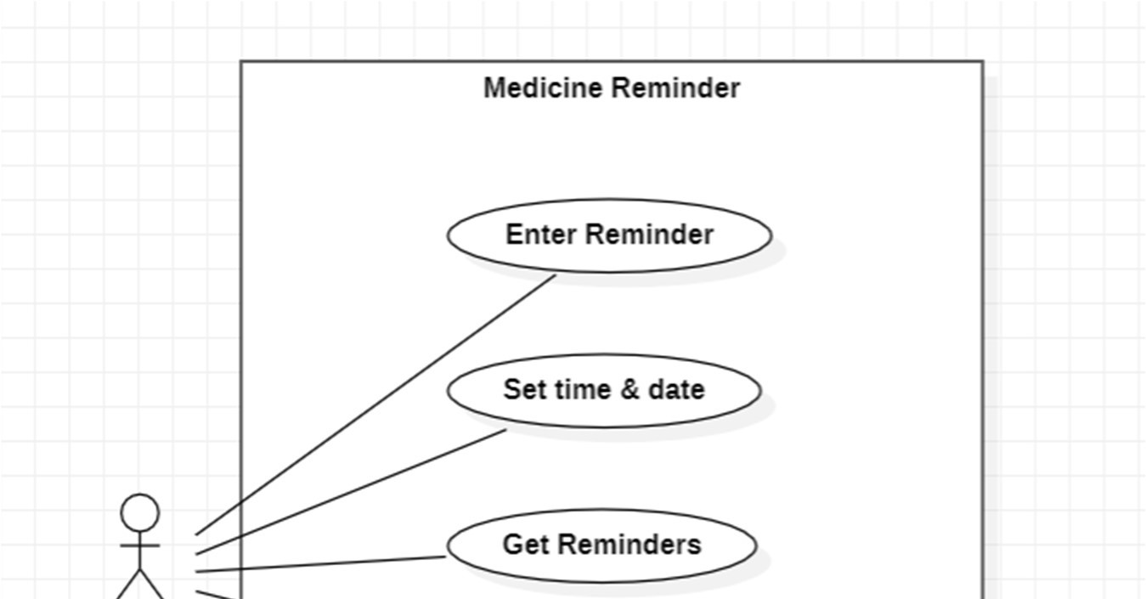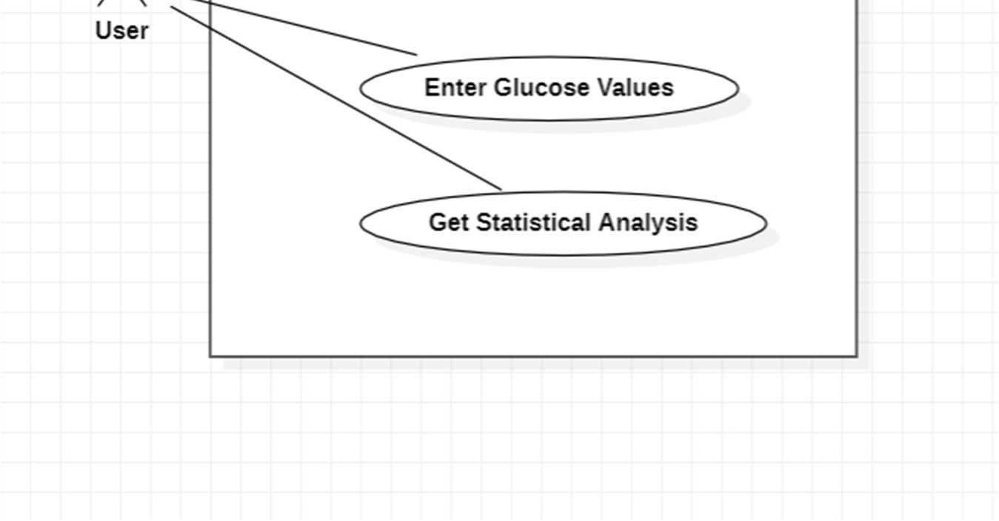

Fig. Use Case Diagram

9.2 Class Diagram:

The use case diagram may be improved with the help of the class diagram, which is also used to define the comprehensive design of the system. The class diagram assigns each of the players that were identified in the use case diagram to one of many classes that are connected to one another. There are two possible ways to describe the connection or link that exists between the classes: "is-a" or "has-a." There is a possibility that each class shown in the class diagram can execute several functions. These built-in capabilities are known as "methods," and they are provided by the class. Aside from that, it's possible for every class to have their own unique "attributes" that help to identify them.

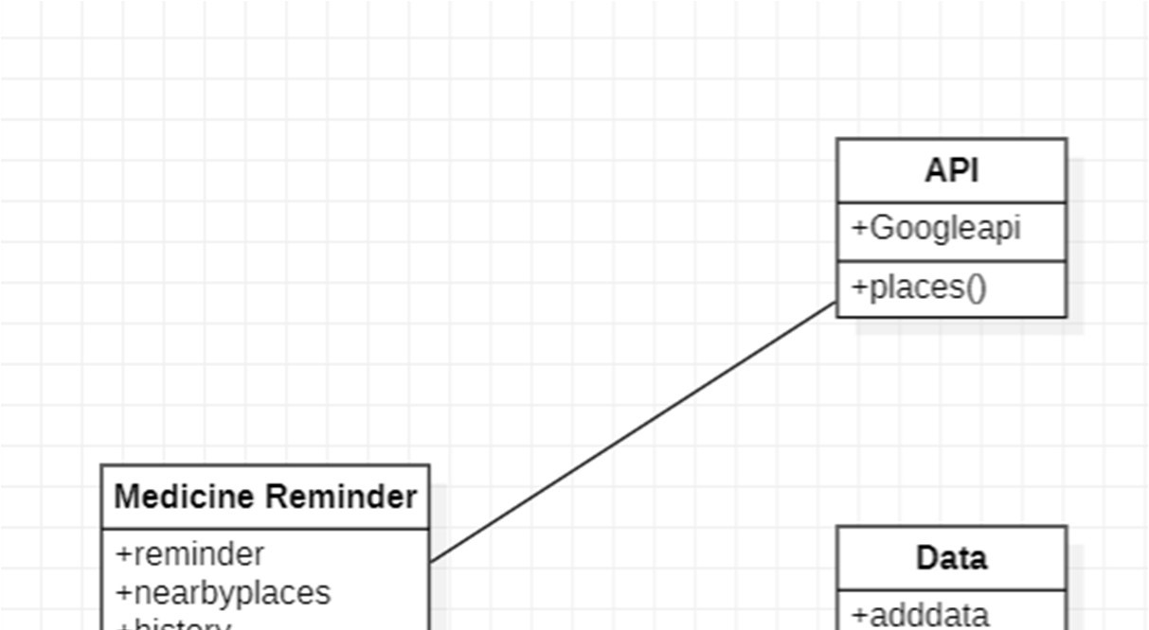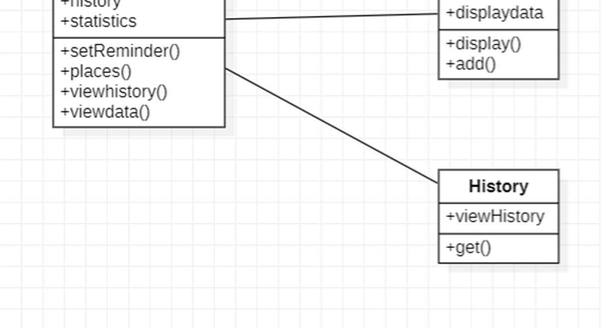

Fig 9.2 Class Diagram

9.3 Object Diagram:

The class diagram is expanded into the object diagram in this way. A class instance is synonymous with an object. This indicates that an object reflects the state that a class was in at a certain instant in time when the system is being executed. The object diagram illustrates the present state of the system's many classes, as well as the ties or linkages between those classes.

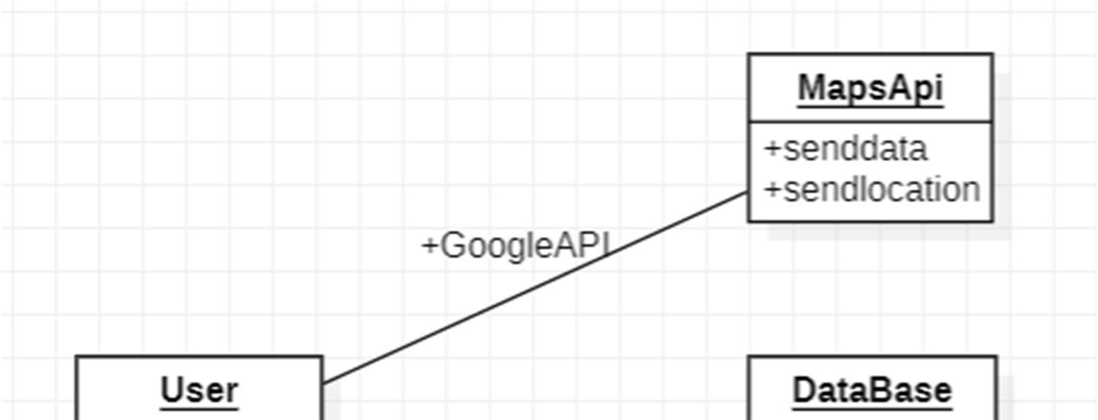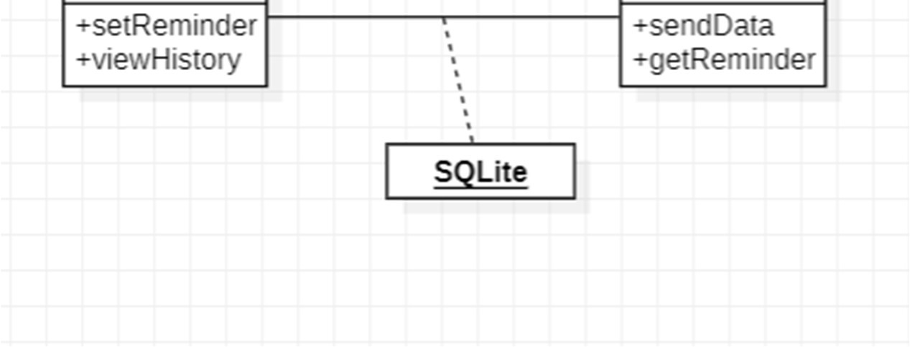

Fig 9.3 Object Diagram

9.4 Activity Diagram:

The activity diagram presents a representation of the system's process flows. A state diagram is similar to an activity diagram in that it consists of activities, actions, transitions, beginning and end states, and guard conditions.

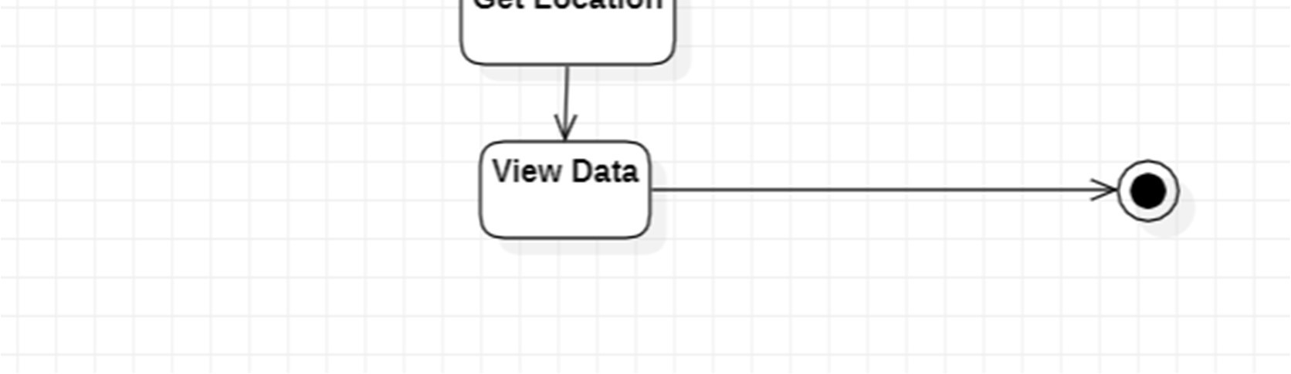

Fig 9.4 Activity Diagram

# 10. IMPLEMENTATION

Creating Java Class:

Java is a programming language which will be used to interact with the application.

Java contains many libraries which are used to create application class and interact with database for backend.

Class files will specify the work of layout xml files, specifying the work that is to be assigned to each attribute.

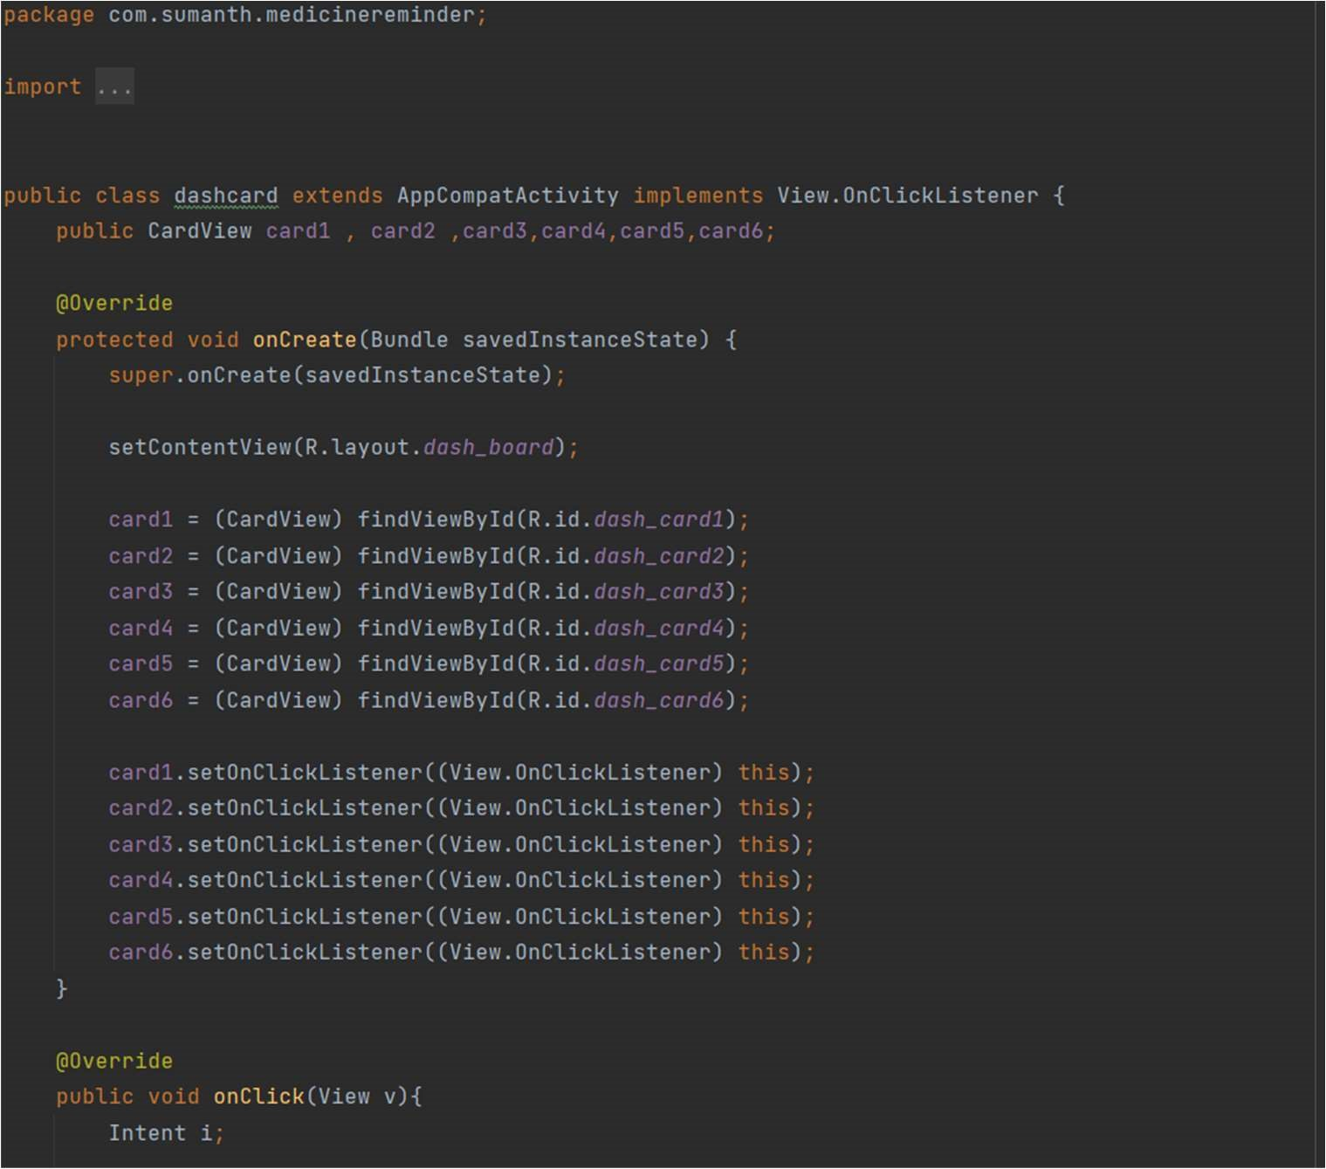

Class is an object of java program; we write the code in java file and in execution it generates a class file. The generated class file is then used for execution of the program.

We’ve created java files for setting reminder, viewing data from database, getting nearby places and uploading document to cloud.

Layout Xml Files:

Layout files are used in designing the application, same such as html. Layout uses xml language to create nodes. Layout files specify the elements involved in designing the application.

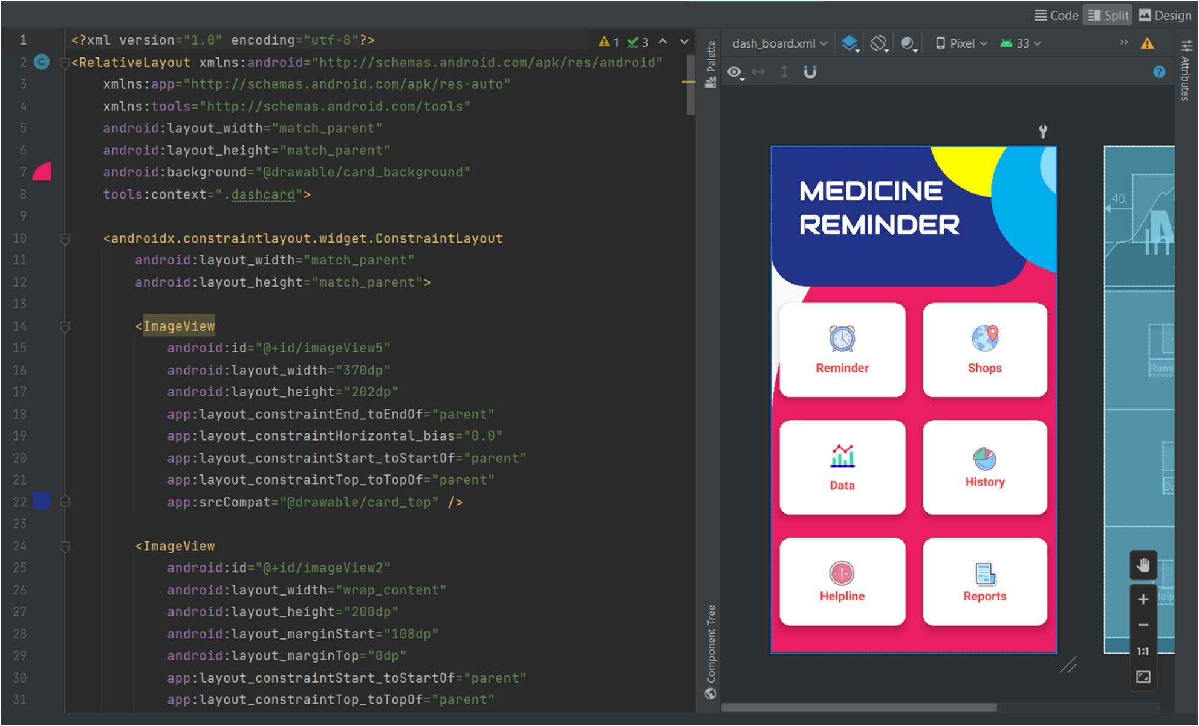

This screen is the main screen of our application and is designed using xml code. Xml code consists of attributes such as Text view, Edit text, Image view.

Application Description:

This app provides features like adding reminders, locating nearby shops, uploading and downloading the records of the user and getting 30 – day analysis of the data.

This app requires min. Android 7.0 (nougat) in order to run & also it uses various dependencies like firebase, google maps, butterknife, MP android chart in order to work. Users can set the reminders for the specific day

and time and accordingly they will get reminders. Users can also add daily values of Blood Pressure and Glucose to get the monthly analysis of the data. Users can upload the medical records to the real time database.

This app requires location services to be enabled to show nearby hospitals, shops & pharmaci

# **11. RESULTS**

**Student’s part:**

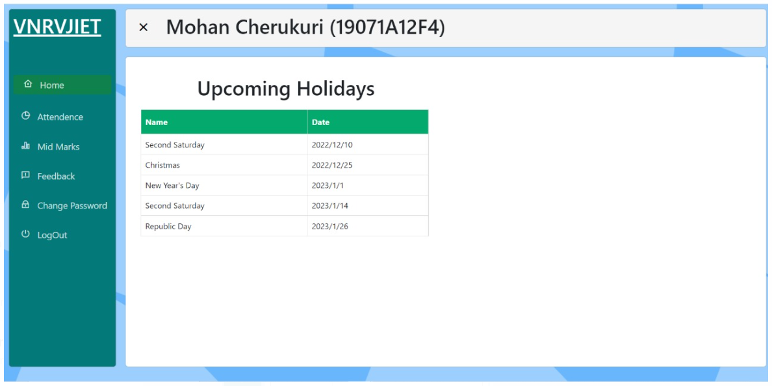

**After successful login**

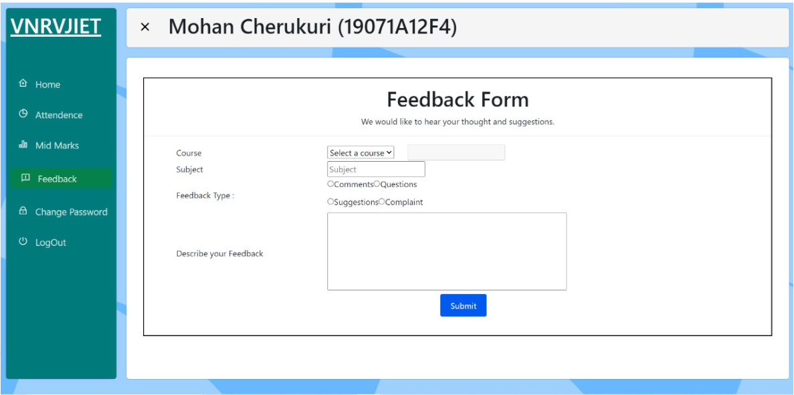

**System displaying the feedback form**

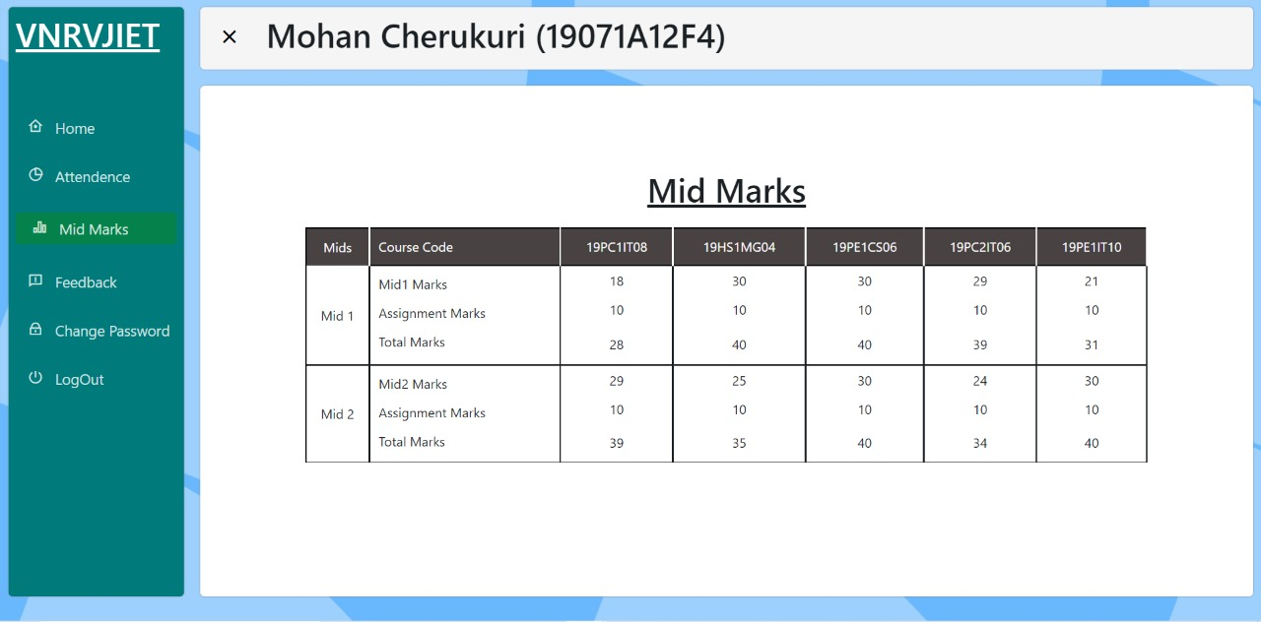

**System displaying the mid marks of a student**

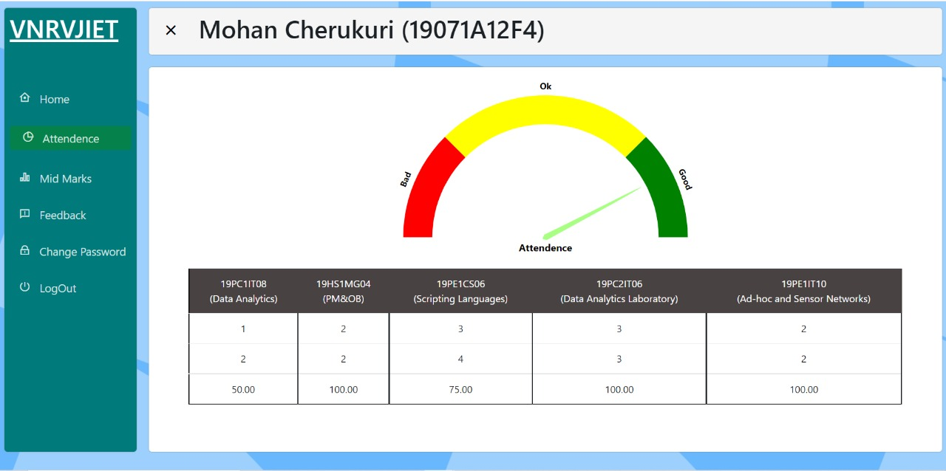

**System displaying Student’s Attendance component**

**TEACHER:**

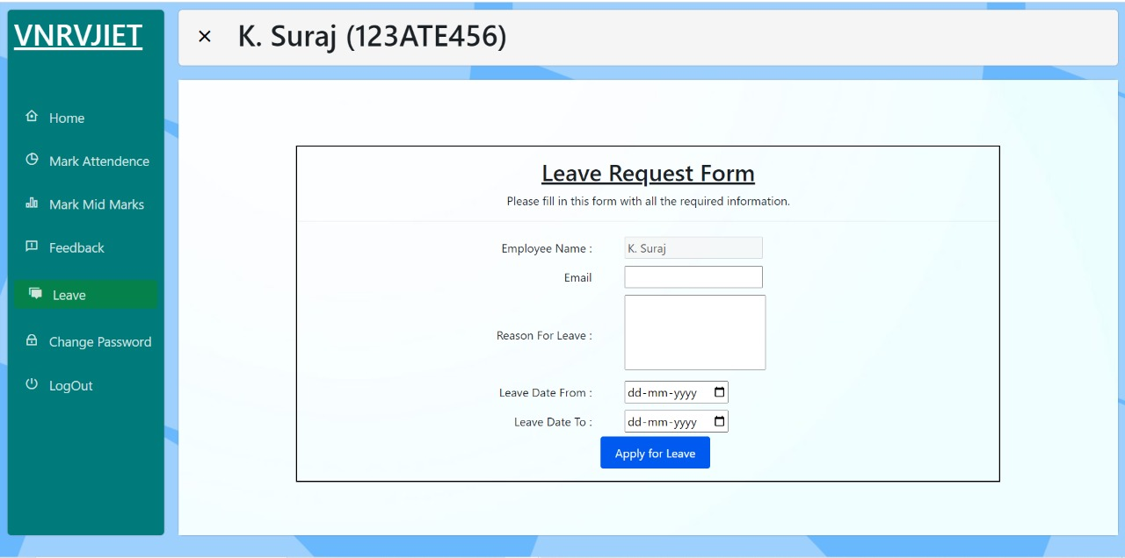

**System displaying the leave request form after teacher successful logging in**

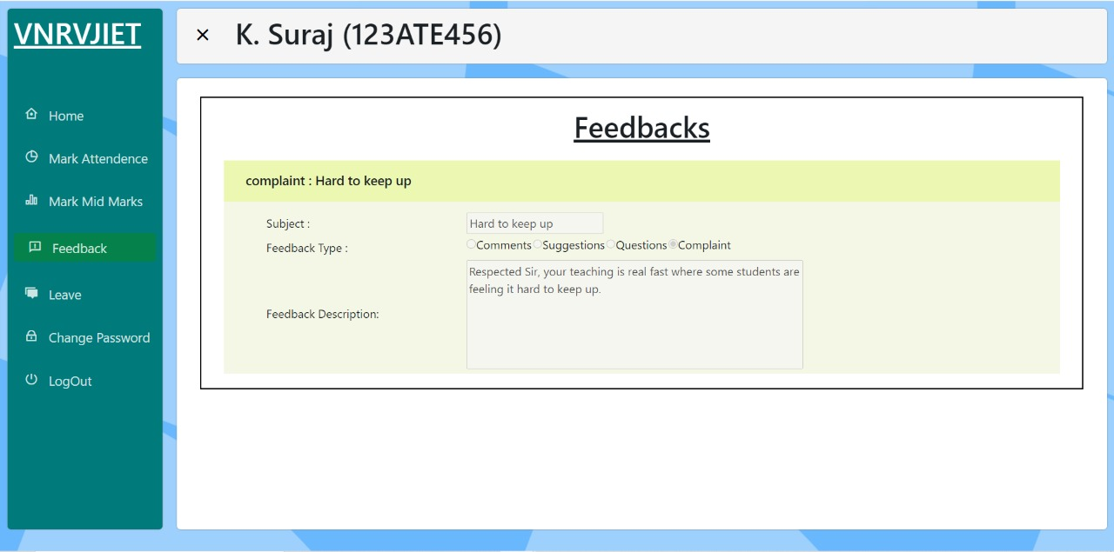

**System displaying the feedback received from Student’s end**

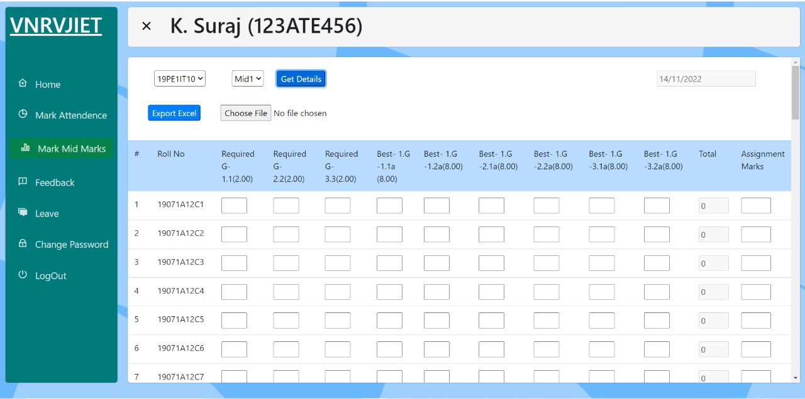

**System displaying mid mark schema component**

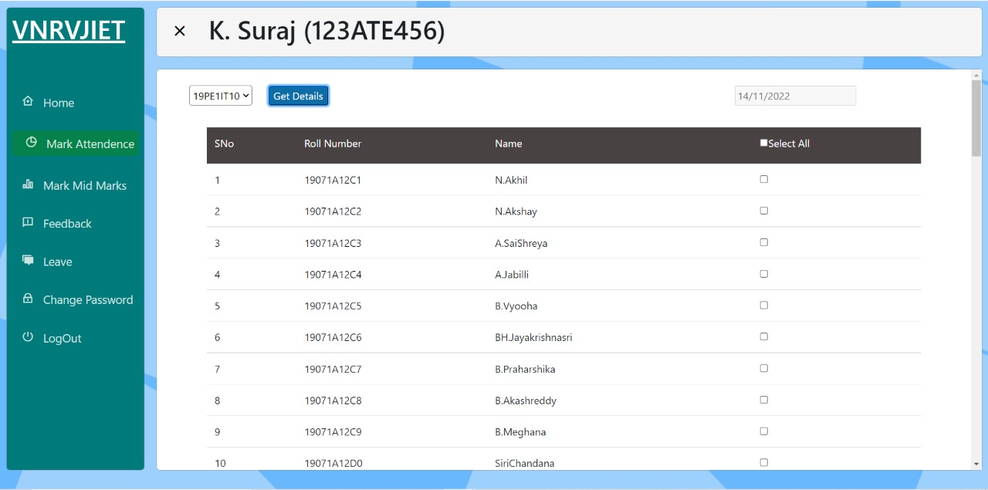

**System displaying the Attendance list details to be marked**

**ADMIN:**

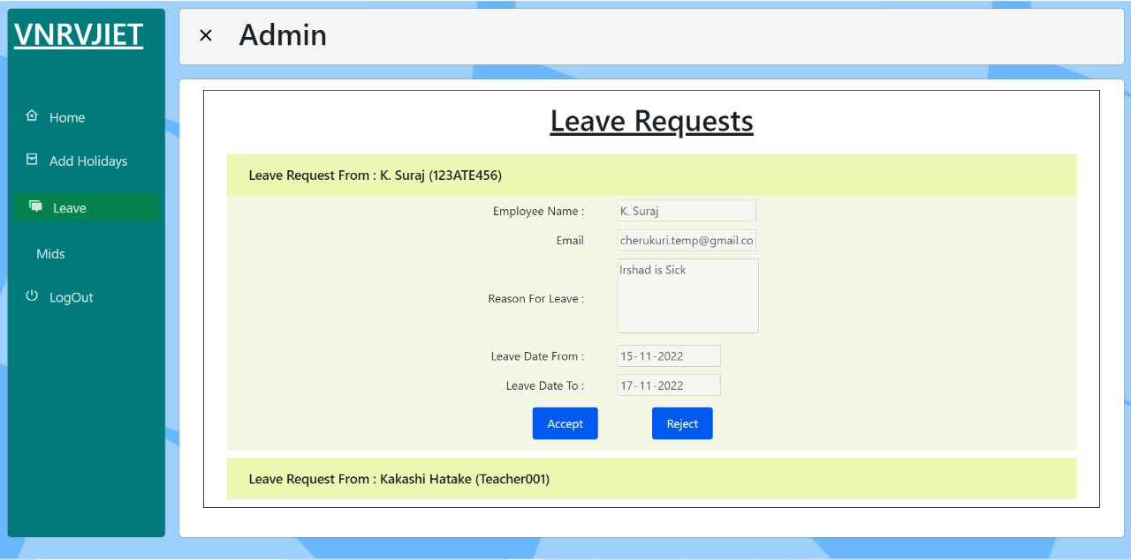

**System displaying the leave request component**

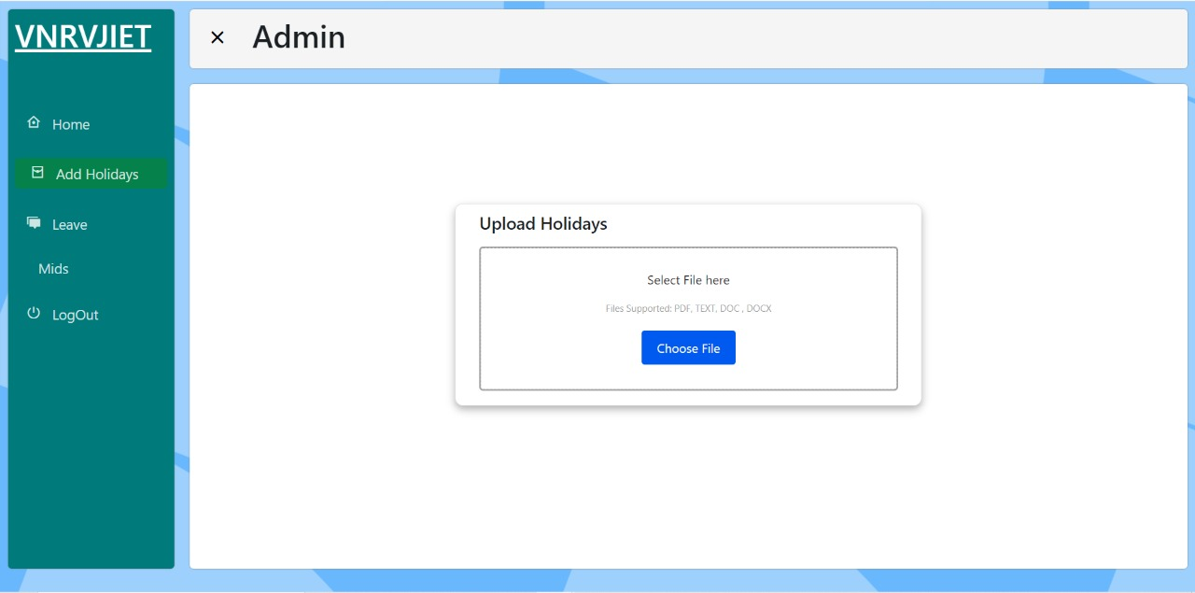

**System displaying the upload holidays component**

# **12. CONCLUSION**

An automated system does reduce the manpower with ease. With just designing the system and the prototype to handle all basic operations is all we need. The Eduprime clone comes with a cloud storage facility provided by google which can store data as an entity where the data can be of any form, whether in string or Boolean or collection of tables. Establishing connection between front-end and back-end is a necessity as well a key step in this project. The system work in different ways based on the login the users made which is in the form of a student, teacher, or the admin. The student once logged in can check their attendance, their academic reports which is their mid marks and a student feedback page. The teacher once logged in can check their student submitted feedback which can be reviewed, marking student’s attendance of different subjects attending, also we implemented the leave request mechanism in which the decision can be decided by the upper management. The admin will be logged to update the mid marks of students and sending the status of leave request to their respective mentioned mails. In Attendance component we can mark all at once and reflect the classes attended to each student, once the student logs in he/she can check her updated attendance. In mid mark section we can import and export the mark sheet in the system in which necessary changes can be done.

# **13. Future Scope**

This automated system can have functionalities like placements component in which the placement related tests, the test result, and the list of companies in board to recruit the students. It also includes the alumni’s insights on how to crack in tech giant companies and other basic requirements to crack placements. The system can add the semester result report along with the mid mark report, it can also calculate the gpa for the current semester and the cumulative semesters occurred. Based on the subscription of cloud storage we can add the entire university data into the system. With accessibility of google development tools into the system like sending emails to the faculty.

# **14. REFERENCES**

* M. Kassim, H. Mazlan, N. Zaini and M. K. Salleh, "Web-based student attendance system using Web technology," 2012 IEEE Control and System Graduate Research Colloquium, 2012, pp. 213-218, doi: 10.1109/ICSGRC.2012.6287164.
* W. Winarno, Y. Muhtadi, and M. A. Aldiya, “Application of Learning Management Using Non-test Instrument to Improve the Quality of Education,” Aptisi Trans. Manag., vol. 3, no. 1, pp. 46–56, 2019.
* S. Bein, Y. I. Graha, and A. P. Pangestu, “Pandawan Website Design Based Content Management System As Media E-commerce Transaction,” Aptisi Trans. Technopreneursh., vol. 2, no. 1, pp. 87–97, 2020.
* Wahab, M.H.A., et al. Web-based laboratory equipment monitoring system, in Intelligent and Advanced Systems (ICIAS), 2010 International Conference on. 2010.